N. ARUN KUMAR 192424184
1: Mental Wellbeing App
<!DOCTYPE html>
<html>
<head>
<meta charset="utf-8">
<style>
body{margin:0;background:#fff;font-family:DejaVu Sans,Arial,sans-serif;}
.row{width:1000px;padding:10px;}
.phone{display:inline-block;vertical-align:top;width:220px;height:420px;margin:8px 10px;border:3px solid #333;border-radius:22px;background:#f3f9f6;overflow:hidden;}
.bar{background:#2e7d6b;color:#fff;padding:12px;font-size:14px;font-weight:bold;text-align:center;}
.body{padding:14px;}
input{width:90%;padding:8px;margin:6px 0;border:1px solid #aaa;border-radius:6px;font-size:12px;}
.btn{background:#2e7d6b;color:#fff;text-align:center;padding:9px;border-radius:6px;margin-top:10px;font-size:13px;}
.link{text-align:center;font-size:11px;color:#2e7d6b;margin-top:10px;}
.card{background:#fff;border:1px solid #cfe5dc;border-radius:8px;padding:10px;margin-bottom:10px;font-size:12px;}
.card b{color:#2e7d6b;}
.cap{text-align:center;font-size:12px;margin-top:4px;}
</style>
</head>
<body>
<div class="row">
<div class="phone"><div class="bar">MindCare - Login</div><div class="body">
<div style="text-align:center;font-size:36px;">&#129496;</div>
<input placeholder="Email"><input placeholder="Password" type="password">
<div class="btn">LOGIN</div><div class="link">New user? Register here</div></div></div>
<div class="phone"><div class="bar">Register</div><div class="body">
<input placeholder="Full Name"><input placeholder="Email"><input placeholder="Password" type="password"><input placeholder="Confirm Password" type="password">
<div class="btn">REGISTER</div><div class="link">Already have an account? Login</div></div></div>
<div class="phone"><div class="bar">Health Routine Blogs</div><div class="body">
<div class="card"><b>Morning Meditation</b><br>10 minutes of breathing to start the day calm.</div>
<div class="card"><b>Stretch &amp; Walk</b><br>Simple daily exercises for body and mind.</div>
<div class="card"><b>Sleep Routine</b><br>Wind-down habits for better rest.</div></div></div>
<div class="phone"><div class="bar">Self-Care Blogs</div><div class="body">
<div class="card"><b>Digital Detox</b><br>Take screen-free breaks every day.</div>
<div class="card"><b>Gratitude Journal</b><br>Write three good things each night.</div>
<div class="card"><b>Stress Relief</b><br>Quick tips to manage anxiety.</div></div></div>
</div>
</body></html>

OUTPUT:

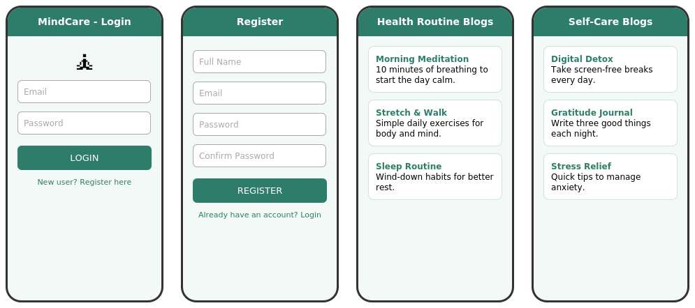

2: Job Assistant App

CODE:

<!DOCTYPE html>
<html>
<head>
<meta charset="utf-8">
<style>
body{margin:0;background:#fff;font-family:DejaVu Sans,Arial,sans-serif;}
.row{width:1250px;padding:10px;}
.phone{display:inline-block;vertical-align:top;width:200px;height:420px;margin:8px 6px;border:3px solid #333;border-radius:22px;background:#f4f6fb;overflow:hidden;}
.bar{background:#3f51b5;color:#fff;padding:12px;font-size:13px;font-weight:bold;text-align:center;}
.body{padding:12px;}
input,select{width:90%;padding:7px;margin:5px 0;border:1px solid #aaa;border-radius:6px;font-size:11px;}
.btn{background:#3f51b5;color:#fff;text-align:center;padding:8px;border-radius:6px;margin-top:10px;font-size:12px;}
.link{text-align:center;font-size:11px;color:#3f51b5;margin-top:10px;}
.card{background:#fff;border:1px solid #c5cae9;border-radius:8px;padding:8px;margin-bottom:8px;font-size:11px;}
.card b{color:#3f51b5;}
.plan{background:#fff;border:2px solid #3f51b5;border-radius:8px;padding:8px;margin-bottom:8px;font-size:11px;text-align:center;}
.up{border:2px dashed #3f51b5;border-radius:8px;padding:22px 6px;text-align:center;font-size:11px;color:#3f51b5;margin:10px 0;}
</style>
</head>
<body>
<div class="row">
<div class="phone"><div class="bar">JobBuddy - Login</div><div class="body">
<div style="text-align:center;font-size:34px;">&#128188;</div>
<input placeholder="Email"><input placeholder="Password" type="password">
<div class="btn">LOGIN</div><div class="link">Create an account</div></div></div>
<div class="phone"><div class="bar">Subscription</div><div class="body">
<div class="plan"><b>Free</b><br>5 job matches / month</div>
<div class="plan"><b>Premium</b><br>Unlimited matches &amp; contract help</div>
<div class="btn">SUBSCRIBE</div></div></div>
<div class="phone"><div class="bar">Personal Detail</div><div class="body">
<input placeholder="Full Name"><input placeholder="Phone"><input placeholder="City"><input placeholder="Qualification">
<div class="btn">SAVE &amp; NEXT</div></div></div>
<div class="phone"><div class="bar">Resume Upload</div><div class="body">
<div class="up">&#128196;<br>Tap to select resume<br>(PDF / DOC)</div>
<div class="btn">UPLOAD</div></div></div>
<div class="phone"><div class="bar">Choose Job</div><div class="body">
<div class="card"><b>Android Developer</b><br>TechSoft - Chennai</div>
<div class="card"><b>UI/UX Designer</b><br>PixelWorks - Remote</div>
<div class="card"><b>Software Tester</b><br>QualityHub - Pune</div>
<div class="btn">APPLY</div></div></div>
</div>
</body></html>
OUT PUT:
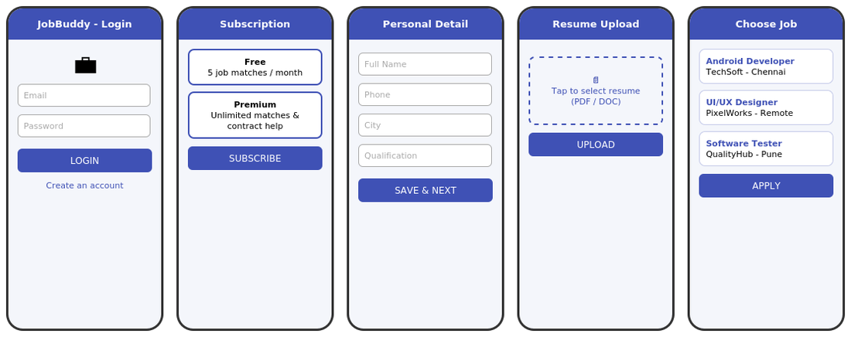

3: Parking Slot App

CODE:
<!DOCTYPE html>
<html>
<head>
<meta charset="utf-8">
<style>
body{margin:0;background:#fff;font-family:DejaVu Sans,Arial,sans-serif;}
.row{width:1000px;padding:10px;}
.phone{display:inline-block;vertical-align:top;width:220px;height:420px;margin:8px 10px;border:3px solid #333;border-radius:22px;background:#fff8ee;overflow:hidden;}
.bar{background:#e65100;color:#fff;padding:12px;font-size:14px;font-weight:bold;text-align:center;}
.body{padding:14px;}
input{width:90%;padding:8px;margin:6px 0;border:1px solid #aaa;border-radius:6px;font-size:12px;}
.btn{background:#e65100;color:#fff;text-align:center;padding:9px;border-radius:6px;margin-top:10px;font-size:13px;}
.link{text-align:center;font-size:11px;color:#e65100;margin-top:10px;}
.big{text-align:center;font-size:44px;font-weight:bold;color:#e65100;margin:14px 0 2px 0;}
.sub{text-align:center;font-size:12px;color:#555;}
.slot{display:inline-block;width:40px;height:34px;margin:4px;border-radius:5px;text-align:center;font-size:12px;line-height:34px;color:#fff;}
.free{background:#2e9e4f;}
.busy{background:#c62828;}
.sel{background:#1565c0;}
.card{background:#fff;border:1px solid #ffcc80;border-radius:8px;padding:10px;font-size:12px;margin-top:8px;}
</style>
</head>
<body>
<div class="row">
<div class="phone"><div class="bar">ParkEasy - Login</div><div class="body">
<div style="text-align:center;font-size:36px;">&#128663;</div>
<input placeholder="Mobile / Email"><input placeholder="Password" type="password">
<div class="btn">LOGIN</div><div class="link">New user? Sign up</div></div></div>
<div class="phone"><div class="bar">Empty Parking Count</div><div class="body">
<div class="sub">Area: T. Nagar, Chennai</div>
<div class="big">12</div><div class="sub">empty slots available</div>
<input placeholder="Enter updated count">
<div class="btn">REGISTER COUNT</div></div></div>
<div class="phone"><div class="bar">Free Parking Slots</div><div class="body">
<div class="sub">Green = Free &nbsp; Red = Full</div>
<div class="slot free">A1</div><div class="slot busy">A2</div><div class="slot free">A3</div><div class="slot busy">A4</div>
<div class="slot free">B1</div><div class="slot free">B2</div><div class="slot busy">B3</div><div class="slot free">B4</div>
<div class="slot busy">C1</div><div class="slot free">C2</div><div class="slot free">C3</div><div class="slot busy">C4</div></div></div>
<div class="phone"><div class="bar">Book Parking Slot</div><div class="body">
<div class="card"><b>Selected Slot:</b> B2<br><b>Location:</b> T. Nagar<br><b>Time:</b> 10:00 - 12:00<br><b>Fee:</b> Rs. 40</div>
<div class="slot sel" style="width:90px;">B2</div>
<div class="btn">CONFIRM BOOKING</div><div class="link">Booking ID: PK1024</div></div></div>
</div>
</body></html>

OUTPUT:
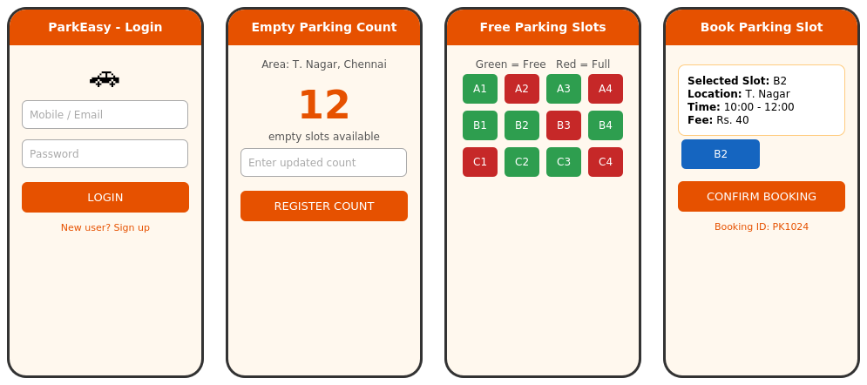

4: Online Fitness App

CODE:
<!DOCTYPE html>
<html>
<head>
<meta charset="utf-8">
<style>
body{margin:0;background:#fff;font-family:DejaVu Sans,Arial,sans-serif;}
.row{width:1500px;padding:10px;}
.phone{display:inline-block;vertical-align:top;width:200px;height:420px;margin:8px 6px;border:3px solid #333;border-radius:22px;background:#f3f6fb;overflow:hidden;}
.bar{background:#c62828;color:#fff;padding:12px;font-size:13px;font-weight:bold;text-align:center;}
.body{padding:12px;}
input{width:90%;padding:7px;margin:5px 0;border:1px solid #aaa;border-radius:6px;font-size:11px;}
.btn{background:#c62828;color:#fff;text-align:center;padding:8px;border-radius:6px;margin-top:10px;font-size:12px;}
.link{text-align:center;font-size:11px;color:#c62828;margin-top:10px;}
.card{background:#fff;border:1px solid #ef9a9a;border-radius:8px;padding:8px;margin-bottom:8px;font-size:11px;}
.card b{color:#c62828;}
.vid{background:#263238;color:#fff;height:90px;border-radius:8px;text-align:center;font-size:30px;line-height:90px;margin-bottom:6px;}
.plan{background:#fff;border:2px solid #c62828;border-radius:8px;padding:8px;margin-bottom:8px;font-size:11px;text-align:center;}
</style>
</head>
<body>
<div class="row">
<div class="phone"><div class="bar">FitLife - Login</div><div class="body">
<div style="text-align:center;font-size:34px;">&#127947;</div>
<input placeholder="Email"><input placeholder="Password" type="password">
<div class="btn">LOGIN</div><div class="link">New here? Register</div></div></div>
<div class="phone"><div class="bar">Register</div><div class="body">
<input placeholder="Name"><input placeholder="Email"><input placeholder="Age / Weight"><input placeholder="Password" type="password">
<div class="btn">REGISTER</div></div></div>
<div class="phone"><div class="bar">Fitness Blog</div><div class="body">
<div class="card"><b>5 Morning Stretches</b><br>Start your day active.</div>
<div class="card"><b>Build a Daily Routine</b><br>Small habits that last.</div>
<div class="card"><b>Hydration Tips</b><br>Why water matters.</div></div></div>
<div class="phone"><div class="bar">Diet Planner</div><div class="body">
<div class="card"><b>Breakfast</b><br>Oats, fruit, boiled egg</div>
<div class="card"><b>Lunch</b><br>Rice, dal, vegetables</div>
<div class="card"><b>Dinner</b><br>Chapati, salad, curd</div></div></div>
<div class="phone"><div class="bar">Fitness Videos</div><div class="body">
<div class="vid">&#9654;</div><div style="font-size:11px;margin-bottom:8px;">Full Body Workout - 20 min</div>
<div class="vid">&#9654;</div><div style="font-size:11px;">Yoga for Beginners - 15 min</div></div></div>
<div class="phone"><div class="bar">Payment</div><div class="body">
<div class="plan"><b>Monthly</b> - Rs. 199</div>
<div class="plan"><b>Yearly</b> - Rs. 1499</div>
<input placeholder="Card / UPI ID">
<div class="btn">PAY &amp; SUBSCRIBE</div></div></div>
</div>
</body></html>

OUTPU:
